Payroll Management System for Information Technology Company

Version 1.0

Revision History

|  |  |  |  |
| --- | --- | --- | --- |
| **Date** | **Version** | **Description** | **Author** |
| 31/10/2019 | 1.0 | Final | Tạ Văn Hiệp |
|  |  |  |  |
|  |  |  |  |
|  |  |  |  |

Table of Contents

1. Adding Feedback 4

1.1 Brief Description 4

1.2 Actor Administrator. 4

2. Flow of Events 4

2.1 Basic Flow 4

3. Special Requirements 5

4. Preconditions 5

5. Postconditions 5

6. Extension Points 5

# Adding Feedback

## Brief Description

This use case defines steps of adding feedback in the system. Account and employee can

easily add feedback in the database.

## Actor Accountant, employee.

# Flow of Events

## Basic Flow

The system accountant or employee selects to add feedback and enters all information of

this feedback to store in the database system. The feedback contains some basic information such as title, description, content, post-date.

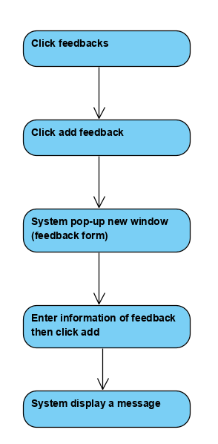



Basic flow of Adding New Feedback

# Special Requirements

No special requirements.

# Preconditions

Login.

# Postconditions

System display message if adding feedback is success or fail.

# Extension Points

No extension points.